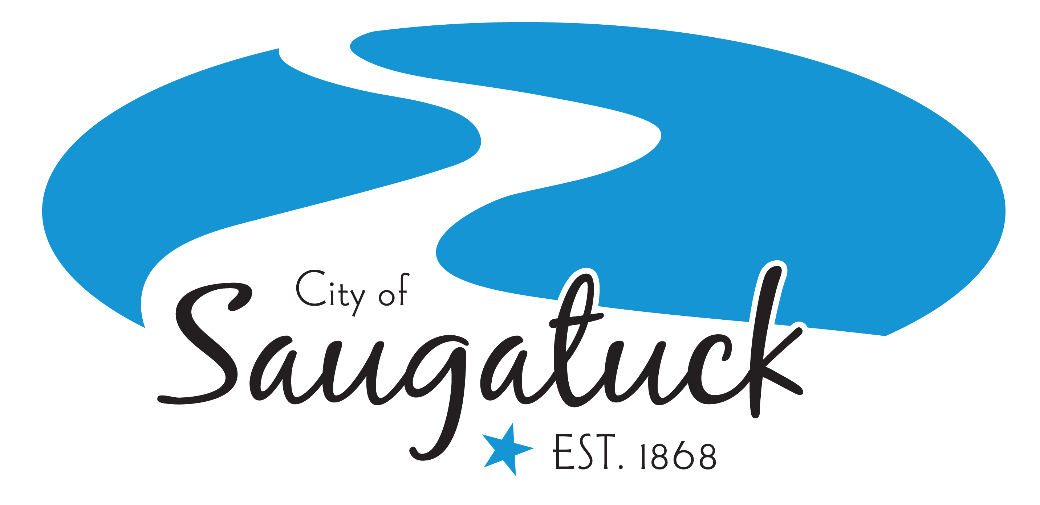
CITY COUNCIL MEETING MINUTES
SAUGATUCK, MICHIGAN, March 14, 2022

The City Council met for Regular Council Meeting at 7:00 p.m. at City Hall, 102 Butler St., Saugatuck, MI 49453.

- Call to Order:
The meeting was called to order by Mayor Lewis at 7:00 p.m.

2. Pledge of Allegiance

3. Attendance:
Present: Mayor Lewis, Mayor Pro-Tem Dean, Council members Gardner, Leo, Stanton and Trester
Absent: Council member Bekken
Others Present: City Manager Heise & Project Coordinator/Deputy Clerk White

4. Consent Agenda:
A. Regular City Council Meeting Minutes – February 28, 2022
B. Public Input Session Meeting Minutes – March 9, 2022
C. Accounts Payable in the amount of $136,265.41
Motion by Trester, second by Dean to approve the Consent Agenda. Motion carried 6-0 by roll call vote.

5. Staff Reports:
City Manager, Treasurer, Zoning Administrator, DPW Superintendent, Police, and Engineer submitted status reports of current activities since the last Council meeting on February 28, 2022 for their respective departments.

Council member Trester asked City Manager Heise to elaborate on the “Milfoil Update” in his report. Heise stated that billing for milfoil treatment last year was messy and that staff is investigating ways to make treatment payment and collection more efficient.

Council member Gardner noted that he would like to see the costs for the Bridge Street project, in reference to Heise’s report. Gardner also noted that the exterior of City Hall is in need of serious repairs and was curious about what happened to the exterior clock that used to hang in front of City Hall.

- Agenda Changes: None

- Guest Speakers: None

- Public Comment on Agenda Items:
Sherry Tedaldi (resident) spoke regarding Item 12-B. Tedaldi stated that the public art installation should be mindful of the natural amphitheater in Coghlin Park, which is great for Venetian Festival music.

9. Introduction of Ordinances: None

10. Public Hearings: None

11. Unfinished Business: None

12. New Business:
- HWA Treatment – Landowner Agreement and Treatment Contribution:
City Manager Heise noted that he would be comfortable increasing the contribution amount from $9,500.00 to $9,950.00. Council member Gardner asked that Ox-Bow be added to the treatment agreement as a co-grantor.

Motion by Trester, 2nd by Leo to approve the landowner agreement form for survey and treatment of Hemlock Wooly Adelgid (HWA) with the Ottawa Conservation District subject to staff and attorney review and approval and approve contributing $9,950.00 for the survey and treatment of HWA within Tallmadge Woods, within City limits. Upon roll call vote, the motion carried 6-0.

- Special Event Application – Saugatuck Center for the Arts Public Art Installation in Coghlin Park:
City Manager Heise noted that there will be turf deterioration over the summer season with the placement of the art sculpture. Council member Stanton asked about making sure that the public art does not interfere with the functions of Venetian Festival. Both Council members Trester and Dean affirmed that a Venetian representative was present at the meeting with the Saugatuck Center for the Arts and that the artist would incorporate the stage placement into their final sculpture footprint. Council member Gardner asked about getting a separate application for the art installation on the west side of the Kalamazoo River.

Motion by Stanton, 2nd by Gardner to approve the special event application from the Saugatuck Center for the Arts for a Quad-Community Art Installation in Coghlin Park, with an installation date of 6.7.2022 and a takedown date of 9.9.2022. Upon voice vote, the motion carried 6-0.

- 2022 Street End Licenses:
City Manager Heise provided a brief overview of the Municipal License Agreements and noted that they expire at the end of 2022. Council member Gardner requested that the City include the name of the Lessees. Council member Stanton recused herself from the vote as her name is on one of the street end license agreements.

Motion by Gardner, 2nd by Trester to approve the 2022 Municipal License Agreement rates as presented on Attachment A and authorize the Mayor and City Clerk to sign such Agreements for 2022 as presented. Upon voice vote, the motion carried 5-0, with Stanton self-recused from the vote.

- Resolution 220314-A – Approval for Submission of MNRTF Grant Application for the Blue Star Non-Motorized Trail:
Mayor Lewis noted her appreciation to the engineers at C2AE for coming to the March 9 public input session and answering questions. She also mentioned her appreciation of the summary of comments in Item 4-B.

Motion by Dean, 2nd by Stanton to approve Resolution No. 220314-A to approve the submission of the Michigan Natural Resources Trust Fund grant application for the Blue Star Non-Motorized Trail. Upon roll call vote, the motion carried 6-0.

- Resolution 220314-B – Extend Advisory Tri-Community Recycling Ad-Hoc Committee:
Mayor Lewis, member of the Advisory Tri-Community Recycling Ad-Hoc Committee, provided a brief overview of the committee.

Motion by Leo, 2nd by Trester to approve Resolution No. 220314-B to extend the lifespan of the Advisory Tri-Community Recycling Ad-Hoc Committee to December 31, 2022 and to reappoint Garnet Lewis, Barry Johnson, Linda Escott and Kelly Roche as the City of Saugatuck’s representatives. Upon roll call vote, the motion carried 6-0.

- Board of Review Alternate Member Appointments:
Mayor Lewis provided a summary of the interview process, which included three interviewees. The Mayor’s appointments for the two open alternate Board of Review positions include Lynne Aspnes and Barbara Lucier, with said terms expiring January 1, 2025.

Motion by Trester, 2nd by Gardner to approve the Mayor’s appointments as presented. Upon voice vote, the motion carried 6-0.

13. Public Comment: None

14. Closed Session:
- Pursuant to MCL 15.268(a) of the Open Meetings Act, the City will enter into closed session to conduct the annual City Manager performance review.

Motion by Gardner, 2nd by Trester to move into a closed session. Upon roll call vote, the motion carried 6-0. Council moved into closed session at 7:36 p.m.

Motion by Trester, 2nd by Stanton to come out of closed session. Upon roll call vote, the motion carried 6-0. Council came out of closed session at 7:53 p.m.

Motion by Trester, 2nd by Leo to give City Manager Ryan Heise a 5% raise in his annual salary. Upon roll call vote, the motion carried 6-0.

Council provided praise to City Manager Heise for his work with the City of Saugatuck over the past year.

15. Communications:
- Blue Star Trail Letters (accepted as information)

16. Boards, Commissions & Committee Reports:
Council member Stanton provided a brief report on the actions of the Historic District Commission meeting on March 3rd, noting that the Commission approved the improvements at Wicks Park Bar & Grille.
Mayor Lewis provided a report on the activities of the Advisory Tri-Community Recycling Ad-Hoc Committee. The Committee is eyeing dates for household hazardous waste day in late May and the event will extend an extra hour from the previous year to ensure people have longer access to this service.

17. Council Comments: None

18. Mayor’s Comments:
Mayor Lewis noted on the success of the Erin-Go-Bark Parade on March 12th. Lewis also reminded Council that there will be a Council training 101 session on March 23rd, stating that the training will be great for Council to better learn their roles and responsibilities. The training session will include the elected bodies for the City of Saugatuck, City of the Village of Douglas, and Saugatuck Township.

- Adjournment:
Motion was made by Trester, 2nd by Dean to adjourn the Council meeting. Upon roll call vote, the motion carried 6-0. The meeting adjourned at 7:58 p.m.

Respectfully Submitted,

________________________
Kate White
Project Coordinator & Deputy Clerk

