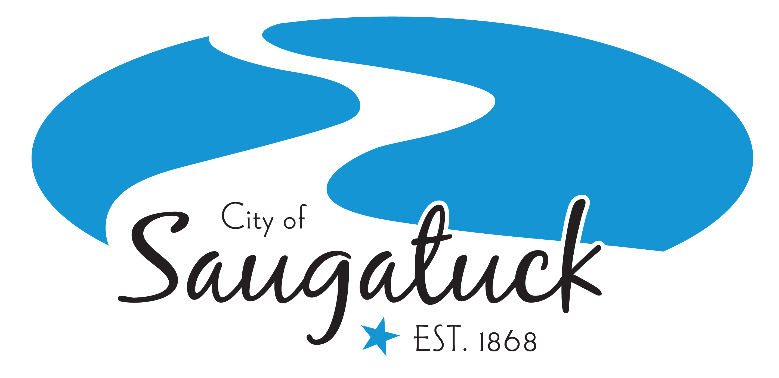
CITY COUNCIL MEETING MINUTES
July 11, 2022

The City Council met for Regular Council Meeting at 7:00 p.m.
City Hall
102 Butler St., Saugatuck, MI 49453.

Call to Order:
The meeting was called to order by Mayor Lewis at 7:00 p.m.

Attendance:
Present: Mayor Lewis, Councilmembers Bekken, Gardner, Leo, Stanton and Trester.
Absent: Dean.
Others Present: City Manager Heise, DPW Superintendent Herbert, Zoning Administrator Osman & Clerk Wolters.

Consent Agenda:
- Special City Council Meeting Minutes – June 22, 2022
- Regular City Council Meeting Minutes – June 27, 2022
- Accounts Payable in the amount of $160,244.28.
Motion by Trester, second by Leo, to approve the consent agenda. Upon roll call vote, motion carried 6-0.

Staff Reports:
City Manager, Treasurer, Zoning Administrator, DPW Superintendent, Police Lieutenant, and Engineer submitted status reports of current activities since the last Council meeting on June 27th, 2022, for their respective departments.

Agenda Change: None

Guest Speakers: None

Public Comment on Agenda Items Only: None

Introduction of Ordinances: None

Public Hearings: None

Unfinished Business: None

New Business:

- Windfeather sign at the Pump House Museum
John Kerr, on behalf of the Saugatuck Douglas History Center submitted a request for City Council to waive the prohibition for a wind feather sign at the Pump House Museum at 735 Park Street.
Motion by Gardner, second by Leo, to approve the request to use a windfeather sign at the Pump House Museum during operating hours as described in the attached request to promote the Saugatuck Douglas History Center’s Mount Baldhead display for this season only. Upon voice vote, motion carried 6-0.

- Lights on Blue Star Bridge
The Kalamazoo Lake Harbor Authority, in support with the Township and City Village of Douglas is recommending the navigational lights be placed on the Blue Star Bridge. Douglas has committed $14,000.00 and Township of Saugatuck has dedicated $4,000.00. The request to Saugatuck City is a match of $14,000.00.
Motion by Trester, second by Gardner, to table the City contribution for the installation of navigation lights on the Blue Star Bridge. Upon roll call vote, motion to table carried 6-0.

Public Comment:
- Maryjo Lemanski, former Saugatuck gallery owner- informed Council of a program she is involved in called the Saugatuck Fennville Arts Initiative. They are donating $4,000 a piece to Saugatuck, Douglas and Fennville to fund an install of an outdoor sculpture in each community. The specific piece of artwork will be announced at a later date.

Correspondence: None

Boards, Commissions & Committee Reports:
- Mayor Lewis- Updated Council on the Tri-Community Recycling Committee report that she passed out to all Council members to review. There will be another Styrofoam collection and she noted the areas around town that paper gators are set up for recycling.
- Councilmember Stanton- Historic District Commission hasn’t met in the last couple months due to no applications submitted. She also noted, the Historic District Commission notice in the packet had the wrong meeting date on it, HDC meets the first Thursday of every month not the fourth.

Council Comments:
- Councilmember Trester- sent kudos to the employees of the Saugatuck Township Fire District for offering to donate their beach passes, he noted it’s a very worthy cause to the less fortunate people and veterans in the Saugatuck Douglas areas. That's a very, very nice community minded gesture. Second, commended all of whom took part in organizing especially Mayor Lewis, the Fourth of July parade and went off without a hitch, it was well organized and, and a good time was had by all.
- Councilmember Bekken- asked DPW Superintendent to describe to Council the state of Mt. Baldhead and what led to the decision to tape off portions of areas.
- Councilmember Leo- Echoed Councilmember Trester’s comments and thanked Mayor Lewis for a great job with the fourth of July parade. She is looking forward to the Parks Committee which is funded and has a mandate to tackle items like Mt. Baldhead very quickly.
- Councilmember Gardner- echoed that comment about fourth of July and noted it was fun to walk out in front of the DPW truck that Scott was driving. He mentioned Council received communication regarding the candy at the parade and thinks that's something that the Council should discuss sooner rather than later. Regarding Council workshops, going forward, if the decision was made to cancel the workshops, he would appreciate Council receiving a reason for that as well as an opportunity to reschedule. He has received notice by Park Street residents that people coming off the Chain Ferry into the street is a danger and there should be signage on which direction to walk and safety barriers for children.
- Councilmember Stanton- thanked Rotary Club for their successful Boys and Girls Club program at the Saugatuck High School.
- Councilmember Bekken- noted there seem to be a lot of younger folks in town, these are the visitors that will keep coming down for future generations.

Mayor’s Comments:
- Mayor Lewis thanked everyone who came to the fourth of July parade and appreciate all the volunteers. She noted she had her family in town, and they had a delightful time.

Adjournment: Motion by Stanton, second by Bekken to adjourn, Mayor Lewis adjourned at 7:38 p.m.

Respectfully Submitted,

____________________
Jamie Wolters, City Clerk

